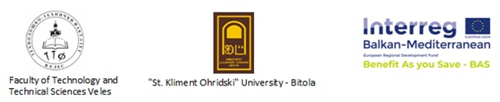
Project: " Stimulating citizens participation to recycle processes
through the implementation of benefits systems"

Benefit As You Save (BAS)

Agenda

For Training Representatives of Educational Institutions on topic:
„Legislative and Management with Aspects of Life Environment
And Climate Changes"
30 September, 2020
(12:00 – 3:00 pm)
ZOOM Platform

- Goals of the BAS Project with a focus on North Macedonia, Prof. d-r. Zora Uzunoska - 45 minutes
- Presentation (First Part) – M-r. sci. Slavjanka Pejcinovska Andonova, Life Environment Engineering, Consultant for Life Environment -30 minutes
  - Influence on Life Environment;
  - Overview of Relevant Legislation for Life Environment Protection;
  - Moto and Goals of Life Environment Legislation;
  - Ovierview of Procedures and Documents for Life Environment Management;
  - Climate Changes (video)
- Discussion – 30 minutes
- Break –15 minutes
- Presentation (Second Part) – 30 minutes
- Goals of Water Legislation, Nature Protection, Air Quality, Waste and Electric Waste;
- Recycling of Various Waste Fractions (video) and Wate Management in Public Institutions;
- State Inspectorate for Life Environment in North Macedonia and Responsibilities of Relevant State Organs;
- Energy Efficiency and Waste Management in Kindergartens and Schools
- Discusion– 30 minutes
- Presentating Content of the Next Training Session and Determining the Date for performance.

